Project Planning Phase
Project Planning Template (Product Backlog, Sprint Planning, Stories, Story points)

Date | 15 February 2025
Team ID
Project Name | AI Blog Nest API
Maximum Marks | 5 Marks

Product Backlog, Sprint Schedule, and Estimation (4 Marks)
Use the below template to create product backlog and sprint schedule for AI Blog Nest API. Each sprint carries 20 story points, for a total of 80 story points across four sprints. Team member entries are roles; replace them with names.
Sprint | Functional Requirement (Epic) | User Story Number | User Story / Task | Story Points | Priority | Team Members
Sprint-1 | Project Setup | USN-1 | As a developer, I can set up the NestJS project with environment config, PostgreSQL (TypeORM) connection and Docker so the team can build on a common base. | 3 | High | Backend Lead
Sprint-1 | Authentication | USN-2 | As a user, I can register by entering my email, password and confirm password. | 2 | High | Backend Dev 1
Sprint-1 |  | USN-3 | As a user, I will receive a confirmation email once I have registered. | 1 | Medium | Backend Dev 1
Sprint-1 |  | USN-4 | As a user, I can log in with email and password and receive JWT access and refresh tokens. | 3 | High | Backend Dev 1
Sprint-1 |  | USN-5 | As an admin, I can assign roles (Admin, Author, Reader) and the API restricts endpoints by role. | 3 | High | Backend Lead
Sprint-1 | Blog Management | USN-6 | As an author, I can create a blog post (saved as a draft) with title, content and cover details. | 3 | High | Backend Dev 2
Sprint-1 |  | USN-7 | As a reader, I can view a list of published posts and open a single post. | 3 | High | Backend Dev 2
Sprint-1 |  | USN-8 | As an author, I can update or delete my own posts. | 2 | High | Backend Dev 2
Sprint-2 | Blog Management | USN-9 | As an author, I can move a post through Draft, Published and Archived states. | 2 | High | Backend Dev 2
Sprint-2 |  | USN-10 | As an author, I can organise posts with categories and tags. | 3 | Medium | Backend Dev 2
Sprint-2 |  | USN-11 | As a reader, I can search, filter, sort and paginate posts. | 3 | Medium | Backend Dev 2
Sprint-2 | AI Content Generation | USN-12 | As a developer, I can integrate an external LLM API through a provider-agnostic AI service module with prompt templates. | 3 | High | AI Developer
Sprint-2 |  | USN-13 | As an author, I can generate a full blog draft by giving a topic, keywords and tone. | 5 | High | AI Developer
Sprint-2 |  | USN-14 | As an author, I can get AI-suggested titles, a summary and a meta description for my post. | 2 | Medium | AI Developer
Sprint-2 |  | USN-15 | As an author, I can get AI-suggested tags and categories for my post. | 2 | Medium | AI Developer
Sprint-3 | AI Content Generation | USN-16 | As an author, I can rewrite selected text in a different tone (formal, casual, technical). | 3 | High | AI Developer
Sprint-3 |  | USN-17 | As an author, I can expand or shorten a section using AI. | 2 | Medium | AI Developer
Sprint-3 | Performance & Security | USN-18 | As a product owner, I want repeated AI requests cached in Redis to reduce cost and response time. | 3 | Medium | Backend Lead
Sprint-3 |  | USN-19 | As a product owner, I want rate limiting on AI endpoints to prevent abuse and control cost. | 2 | High | Backend Lead
Sprint-3 | Blog Management | USN-20 | As an author, I can view a post’s version history (including AI edits) and roll back to a previous version. | 3 | Medium | Backend Dev 2
Sprint-3 | Authentication | USN-21 | As a user, I can reset a forgotten password through an email link. | 2 | Medium | Backend Dev 1
Sprint-3 |  | USN-22 | As a user, I can register and log in through my Google account. | 3 | Low | Backend Dev 1
Sprint-3 | Documentation | USN-23 | As a developer, I can read interactive Swagger (OpenAPI) documentation for every endpoint. | 2 | High | Backend Lead
Sprint-4 | Quality & Testing | USN-24 | As a developer, I want unit tests for the auth, posts and AI service modules. | 3 | High | QA / Tester
Sprint-4 |  | USN-25 | As a developer, I want end-to-end tests covering the main API flows. | 3 | High | QA / Tester
Sprint-4 |  | USN-26 | As a developer, I want global validation, exception filters and logging for consistent error responses. | 2 | Medium | Backend Dev 1
Sprint-4 | Integrations & SEO | USN-27 | As a third-party developer, I can use an API key to access the API from my own application. | 3 | Low | Backend Dev 2
Sprint-4 |  | USN-28 | As an author, I get auto-generated slugs and AI keyword suggestions to improve SEO. | 3 | Low | AI Developer
Sprint-4 | Deployment | USN-29 | As a developer, I can build and test the project automatically through a CI/CD pipeline. | 3 | High | Backend Lead
Sprint-4 |  | USN-30 | As a product owner, I want the API deployed to a cloud environment with production configuration. | 3 | High | Backend Lead
Project Tracker, Velocity & Burndown Chart: (4 Marks)
Sprint | Total Story Points | Duration | Sprint Start Date | Sprint End Date (Planned) | Story Points Completed (as on Planned End Date) | Sprint Release Date (Actual)
Sprint-1 | 20 | 6 Days | 24 Feb 2025 | 01 Mar 2025
Sprint-2 | 20 | 6 Days | 03 Mar 2025 | 08 Mar 2025
Sprint-3 | 20 | 6 Days | 10 Mar 2025 | 15 Mar 2025
Sprint-4 | 20 | 6 Days | 17 Mar 2025 | 22 Mar 2025
Total | 80 | 24 Days | 24 Feb 2025 | 22 Mar 2025
Sprint dates run Monday to Saturday (6 days). Fill in the last two columns as each sprint finishes.
Velocity:
Imagine we have a 10-day sprint duration, and the velocity of the team is 20 (points per sprint). Let’s calculate the team’s average velocity (AV) per iteration unit (story points per day).
AV = velocity ÷ sprint duration = 20 ÷ 10 = 2 story points per day
For AI Blog Nest API: velocity is 20 story points per sprint and each sprint lasts 6 days, so AV = 20 ÷ 6 ≈ 3.33 story points per day.
Burndown Chart:
A burn down chart is a graphical representation of work left to do versus time. It is often used in agile https://www.visual-paradigm.com/scrum/what-is-agile-software-development/ software development methodologies such as https://www.visual-paradigm.com/scrum/scrum-in-3-minutes/ Scrum. However, burn down charts can be applied to any project containing measurable progress over time.
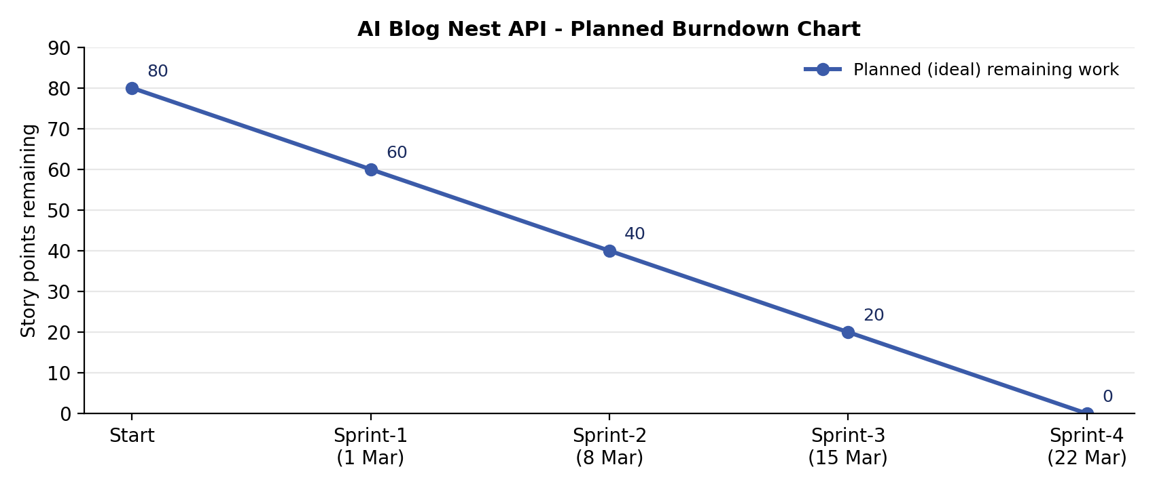
The chart shows the planned (ideal) burndown. Record the actual points remaining at the end of each sprint in the table on the next page and add them to the chart as the project progresses.
Burndown data:
Sprint (end of) | Ideal points remaining | Actual points remaining
Start | 80
Sprint-1 | 60
Sprint-2 | 40
Sprint-3 | 20
Sprint-4 | 0

https://www.visual-paradigm.com/scrum/scrum-burndown-chart/
https://www.atlassian.com/agile/tutorials/burndown-charts
Reference:
https://www.atlassian.com/agile/project-management
https://www.atlassian.com/agile/tutorials/how-to-do-scrum-with-jira-software
https://www.atlassian.com/agile/tutorials/epics
https://www.atlassian.com/agile/tutorials/sprints
https://www.atlassian.com/agile/project-management/estimation
https://www.atlassian.com/agile/tutorials/burndown-charts

